 

Bao la Kiswahili

Rules ”Bao la Kiswahili“

*Bao is a traditional East-African game from the Mancala family (”board game“) that exists in many shapes and variations of rules. The version “Bao la Kiswahili”[1] is called the King of Mancala games.*

# Table of Contents

Table of Contents 2

Idea of the game 3

Game board and terms 3

Gameplay 4

Game setup 4

Game phases 4

End of game 4

General rules 4

Sowing 4

Harvesting 5

Game move 5

Sowing phase (“kunamua”) 6

New seed 6

Move without capture (“kutakata“) 7

Move with capture (“mtaji“) 8

Multiple harvests and reversal of direction 8

The house (“nyumba“) 10

Harvesting phase (“mtaji”) 11

Move without capture („kutakata“) 11

Move with capture (“mtaji“) 12

Blocking (“kutakatia“) 13

The house (“nyumba“) 14

End of game 14

Variation Bao for beginners (“Bao la Kujifunza”) 15

Variation Bao for kids (“Hus bao”) 15

Contact 15

# Idea of the game

The game is played on a board with rows of pits which can hold tokens (“seeds”). The players place and move seeds on the board, trying to protect their own ones and capturing the ones from the opponent.

# Game board and terms

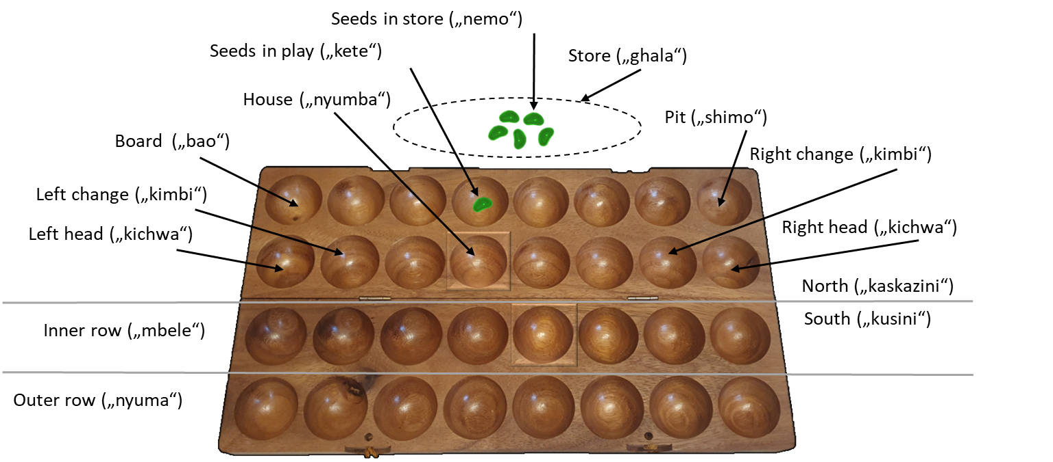

The board consists of 4 rows with 8 pits each. In total, there are 64 tokens (“seeds”), which can be situated in a pit or in the store (e.g., in front of the board). Placing a token on the board is called sowing (“weka”). Capturing a token from the opponent is called harvesting (“kula”).

Each player (North and South) owns one half of the board with 2 rows. The adjacent rows are called the inner rows and here harvesting can take place. The other ones are called the outer rows and here seeds are protected from harvesting.

There are 4 types of pits:

* The house (“nyumba”) is a special square-shaped pit for which special rules exist. In the course of the game, it can lose its privileges and become a regular pit.
* Head (“kichwa”) refers to the 2 outer pits in the inner row. Sowing new seeds takes place here.
* Change[2] (“kimbi”) refers to the 2 rows besides the outer pits of the inner row. Direction of sowing can change here.[3] Since change of direction can also take place in a “kichwa”, “kimbi” can used as a term for both types of pits.
* All other pits are just holes (“shimo”).

# Gameplay

## Game setup

Each player gets half of the total seeds[4]. From those, he puts 6 in his house (the square-shaped pit) and 2 in each of the pits following to the right. The remaining 22 seeds are placed in front of the board. The starting player is determined by lot and is called “South”, his opponent “North”.



## Game phases

The game consists of 2 phases:

* In the sowing phase (“kunamua”), the seeds are placed on the board. In that stage, moves of sowing and harvesting already take place. The players alternately place one new seed at a time into a pit and execute a move. The phase ends, if all seeds are placed on the board.
* In the harvesting phase (“mtaji”), each player tries to capture as many seeds from his opponent as possible. The players alternately decide on a pit to start and a direction to move and execute it until the conditions for end of game are reached.

## End of game

The end of game is reached if one of the following 3 conditions is met:

* A player has no seed left in his inner row.
* A player cannot execute a legal move.
* A player gives up.

# General rules

## Sowing

The distribution of seeds in consecutive rows is called sowing. Sowing is carried out in a direction, either clockwise or counterclockwise, along the 2 rows of a player. 1 seed is placed in each consecutive pit following the selected direction without changing it. Sowing can also mean placing a single seed only.

Sowing starts either in an adjacent pit of the player, from which seeds were extracted or in one of the “kichwa” if opposing seeds are placed on the players side of the board.

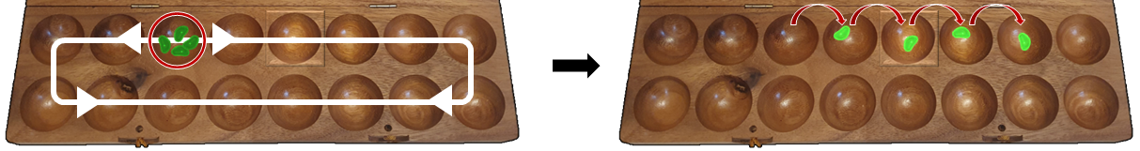

*Example: (1) Sowing takes place by emptying one’s pit. The player extracts all the seed of the selected pit and chooses a direction for the move, here he decides for clockwise. (2) Then he distributes the 4 seeds in the following 4 pits in this direction.*

**

*Example: (1) Here sowing happens by placing opposing seeds newly on one’s side. This must start at a “kichwa” and happen in direction of the house. (2) The player places the 3 seeds in the first 3 pits of the inner row starting at the left ”kichwa”.*

## Harvesting

Capturing seeds from adjacent opposing pits is called harvesting. It becomes available if a previous sowing ends in a non-empty own pit and the directly adjacent opposing pit holds seeds. As a basic principle, if harvesting is possible, the player is obliged to harvest.

Harvesting starts with extracting all the seeds of the opponent’s pit and sowing them immediately starting at one of the outer pits in the inner row in the direction of the own house. Which outer field can be selected will be described later.



*Example: (1) The player sowed a seed in the 6th pit of the inner row. (2) In the adjacent opposing pit, he finds seeds, so he harvests them and immediately sows them from the right “kichwa”.*

## Game move

A move of a player consists of a sequence of sowings and harvests. The result of the initial sowing determines the type of move:

* Clean-up move (“kutakata”): The initial sowing did not lead to a harvest because either the last seed was placed in an empty pit or the adjacent opposing pit was empty. By that, in the course of the move, no harvests are allowed anymore.
* Harvesting move (“mtaji”): The initial sowing led to a harvest because the last seed was placed in a non-empty pit and the directly adjacent opposing pit holds seeds. By that, in the course of the move, further harvests are allowed.

The result of an action determines the next possible actions:

* If a sowing ends in a non-empty pit and harvesting is allowed due to a harvesting move, the opposing seeds are placed on the player’s side and the move is continued.
* If a sowing ends in a non-empty pit, but harvesting is not possible, the move continues with a consecutive sowing (“kuendelea”). The direction of the previous sowing will be kept.
* If sowing ends in an empty pit, the move ends (“kulala”). Additional situations where a move ends are described later.

For protection from theoretically possible infinite[5] moves, a move must consist of no more than 12 laps around the board. If a move takes longer, the player loses immediately.

# Sowing phase (“kunamua”)

In the 1st phase of the game seeds are taken from the store and placed on the board. In this phase, each player alternately sows a new seed into a pit until the store is empty. If both stores are empty, the phase ends.

## New seed

Each move starts with sowing a new seed from the store into a non-empty pit of the inner row. The house is only available for this move, if a harvest of opposing seeds is possible or if it is the last remaining non-empty pit in the inner row.

If a harvest is possible, the player is obliged to harvest. If several harvests are possible, the player may choose.



*Example: At the start of the game, only the 6th and 7th pit of the inner row are available for the move, since they are non-empty. The house must not be selected, because other non-empty pits are available and no harvest is possible.*

**

*Example: Here, a harvest is possible in 3 different pits, because they are non-empty and the directly adjacent opposing pits hold seeds. Also, the house may be selected, since a harvest is possible from there. The latter is even the best available move, since the opposing seed threatens the player’s house, because the opponent would be able to harvest it in his next move.*

## Move without capture (“kutakata“)

If no harvest is possible, a clean-up move is executed. That means, all the seeds of the pit where the new seed was just placed are extracted and sown starting at an adjacent own pit. The player may choose the direction freely, since it is the start of the move.

Following the general sowing rule, the current sowing can result in another sowing, if the last seed falls into a non-empty pit. Since the initial sowing did not result in a harvest, there are no harvest allowed during the rest of the move. While sowing consecutively, the direction of sowing must be kept.



*Example: (1) The player is not able to harvest. He sows a new seed into the 6th pit of the inner row. (2) Then he extracts all the seeds again and chooses clockwise as direction for the sowing. Finally, he sows 1 seed in each of the following 3 pits. Because the last seed falls into an empty pit, the move ends.*



*Example: (1) The player is again not able to harvest and selects the 6th pit of the inner row and clockwise direction for his move. (2) He extracts all the seeds and sows them in the selected direction. This time, the last seed falls into a non-empty pit. (3) The player again extracts all the seeds and sows further in the same direction, which then ends in an empty pit and ends his move. If by consecutively sowing seeds the inner row were reached again, it would still not be allowed to harvest even if adjacent opposing seeds are present, since the initial sowing did not result in a harvest.*

## Move with capture (“mtaji“)

If a harvest is possible, the player is obliged to harvest and has to execute a capture move. This means, he extracts the adjacent opposing seeds and sows them on his side of the board starting from a “kichwa” in the following way:

* If a harvest takes place in the 2 first pits of the inner row, the sowing starts from the left “kichwa” in the direction of the house, thus clockwise.
* If a harvest takes place in the 2 last pits of the inner row, the sowing starts from the right “kichwa” in the direction of the house, thus counterclockwise.
* If a harvest takes place in the inner 4 pits of the inner row, the player can choose the “kichwa” to start from, but must sow towards the house.



*Example: (1) The player is able to harvest. He sows a seed from the store into his house. (2) Then he extracts the opposing seed and is allowed to choose a “kichwa”, since he harvested one of the inner 4 pits. He chooses the right one and sows the seed there. Because the pit was empty, his move ends.*



*Example: (1) The player is able to harvest from the 2nd and 6th pit. He chooses the 2nd one and sows a seed from his store there. (2) Then he extracts the opposing seeds and sows them, starting from the left “kichwa”, because the harvest took place in a “kimbi”. After the sowing, his move ends due to an empty pit.*

## Multiple harvests and reversal of direction

If the initial sowing starts with a harvest, thus resulting in a harvest move, more harvests are allowed during the move. The harvests can either follow directly one after another or multiple sowings can occur before the next harvest takes place.

As a basic principle, the direction of sowing is kept throughout all these sowings and harvests, so always the “kichwa” is chosen, which leads in the previous direction towards the house. This is both true for a sowing from a harvest and multiple sowings in a row.

Only if the last seed of a capture move falls into one of the 2 outer pits of each side of the inner row (“kimbi”, “kichwa”), the nearest “kichwa” has to be chosen. Since sowing from the “kichwa” always takes place towards the house, this can result in the reversal of direction.



*Example: (1) The player sows into the house and harvests the opposing seed. (2) He yet hast the free choice which “kichwa” to start with and chooses the right one. He sows the captured seed there. (3) This leads to another sowing, of which the last seed again allows for harvesting. (4) The sowing starts from the same „kichwa“ again to keep the previous direction (even though the move ends and no moving in a direction occurs).*



*Example: (1) The player sows into the 6th pit of the inner row. This allows him to capture the amount of 7 seeds. (2) He yet has the free choice which “kichwa” to start with and chooses the right one. (3) The last seed of the following sowing allows for a harvest. But now, he has to choose the left “kichwa”, since the harvest took place in the left “kimbi”. And because sowing from the “kichwa” must always take place towards the house, this overrules keeping the direction, thus reversing it. The sowing ends in a non-empty pit but without a harvest. (4) The move is continued with another sowing, which finally ends in the house. The player decides to end his move here (see next chapter).*

## The house (“nyumba“)

The square-shaped pit, called house (“nyumba”), has special rules. This persists until the house is emptied by a harvest from the opponent or by the player himself, emptying it during a move with capture by continue sowing from it (“safari”). By this, the house is destroyed for the rest of the game.

If during a move without capture the last seed falls into the house, the move ends. If the same occurs during a move with capture, the player can decide whether to stop his move there or continue sowing and thus destroying his house.



*Example: (1) A previous move with capture (see previous chapter) ends in the house. The player can decide to stop his move, but wants to continue sowing. (2) He extracts all the seeds of his house and sows them in the same direction. By this, he destroyed his house for the rest of the game (“safari”).*

A new seed from the store may be placed into the house only if it is the last non-empty pit in the inner row. Then, a special sowing action occurs (“taxation”). For that, after placing the seed, exactly 2 seeds are extracted and sown in a chosen direction[6]. By that, it can happen, that the house is left with less than 6 seeds. It then temporarily loses its privileges, but may regain its functionality if it collects at least 6 seeds again during the course of the game.



*Example: (1) The house is the only non-empty pit of the inner row which the player owns and he is not able to harvest. By that, he must choose the house for his sowing. (2) Then he extracts exactly 2 seeds from the house again and sows them in the chosen direction, which here is counterclockwise. After the move the house is left with less than 6 seeds, so it is no longer a functional house, until it regains at least 6 seeds.*

If the house is destroyed or temporarily inactive, a move without capture must start in a pit with at least 2 seeds (instead of only having to be non-empty as before). Only if there is no pit left with more than 1 seed, a move without capture may start from there.

# Harvesting phase (“mtaji”)

As soon as all seeds from the store have been placed on the board, the 2nd phase of the game begins. As before, there are moves with capture and without capture. And still, the rule applies, that if a harvest is possible, the player is obliged to harvest. If several harvests are possible, the player may choose.

A move always starts with choosing a pit with at least 2 seeds and sowing those seeds in a direction of the player’s choice. Whether this leads to a move with or without capture is determined by the last seed of this initial sowing.

There is one more restriction: If a pit contains more than 16 seeds[7], it is not allowed for starting a move with capture. If it gets played anyway, it is regarded as a move without capture.

## Move without capture („kutakata“)

If no possible initial sowing leads to a harvest, a clean-up move is executed. By this, there are no further harvests possible in the course of the move even if a later situation would normally allow for harvesting.

If possible, a pit of the inner row has to be chosen. A pit from the outer row may only be selected, if no pit of the inner row contains more than 1 seed.

The player extracts all seeds of the chosen pit and sows them in the direction of choice. If the last seed falls into a non-empty pit, the sowing gets continued with the seeds of this pit, keeping the previous direction.



*Example: (1) The player is not able to harvest, since no pit which would allow for harvesting is directly reachable from a pit with at least 2 seeds, so he must execute a move without capture. He has to select a pit from the inner row, if possible, so here he can choose between the 4th and the 7th pit. He chooses the 4th pit and clockwise direction. (2) Then he extracts the 3 seeds and sows them in the next 3 pits, clockwise. (3) The last seed falls into a non-empty pit, so he continues sowing in the same direction. Now, the last seed falls into an empty pit and the move ends.*



*Example: (1) The player is again not able to harvest. Additionally, no pit of the inner row contains more than 1 seed. So, he must choose a pit from the outer row, where the 5th and 8th pit are available. He chooses the 8th pit and counterclockwise direction. (2) He sows the 2 seeds in the selected direction and ends the sowing in a non-empty pit. (3) So, he continues his move with another sowing. Again, he falls into a non-empty pit with his last seed and also, the adjacent opposing pit contains seeds. Nevertheless, he is not allowed to harvest them, since he started his initial sowing without a capture. (4) He thus continues his move with another sowing which finally ends in an empty pit.*

## Move with capture (“mtaji“)

If a harvest is possible with any initial sowing, the player must harvest and thus executing a move with capture. By that, further harvests are possible during the course of the move.

If the initial sowing is done, just like in the 1st phase, the seeds of the adjacent opposing pit are extracted and sown, starting from one of the “kichwa” in the direction of the house. The same rules apply as before:

* If a harvest takes place in the 4 inner pits, the direction of the move is kept. Thus, the “kichwa” has to be chosen, which leads to the house when sowing in the same direction as before.
* If a harvest takes place in the 2 outer pits of each side of the inner row (“kimbi”, “kichwa”), the nearest “kichwa” has to be chosen. This may reverse the direction, since the sowing has to take place in the direction of the house.

Several sowings (“kuendelea”) may occur between 2 harvests. The move continues until the last seed of a sowing falls into an empty pit.



*Example: (1) The player is able to harvest, so he must harvest. He can choose between the 2nd and 3rd pit, because, clockwise in each case, a pit is reached where the player can harvest. Also, the 7th pit of the outer row is allowed to choose, since by sowing counterclockwise from there, a harvestable pit of the inner row is reached again. Only, the 6th pit of the outer row is not possible to select, since a counterclockwise sowing would reach the inner pit only after another sowing. The player chooses the 2nd pit of the inner row and clockwise direction. (2) He sows 3 seeds in this direction and reaches a pit where a harvest is possible. (3) In order to keep the direction, he has to select the left “kichwa” for sowing the captured seeds. From there he reaches another non-empty pit. (4) Now, no harvest is possible, thus the move continues with another sowing in the same direction which again reaches a non-empty pit. (5) This time, a harvest is possible. But now the sowing has to start from the right “kichwa”, since the capture took place in one of the outer pits of the inner row (“kimbi”). Thus, the direction is reversed and is now counterclockwise. Finally, the last seed falls into an empty pit and the move ends.*

## Blocking (“kutakatia“)

If the player, after a move without capture, ends his move in a situation where exactly one harvest would be possible the next time, then his opponent is not allowed to move away those threatened seeds with a move without capture. Thus, the opponent’s pit is blocked.

The following pits may not be the subject of blocking:

* A functional house (see next chapter).
* The last remaining pit of the inner row.
* The last remaining pit with at least 2 seeds of the inner row.

The player should point out this situation by saying “hizi zetu” (“these are mine”).

His opponent is then neither allowed to choose the blocked pit for a direct move without capture from this pit, nor may he empty that pit by a sequence of sowings following a move without capture. If a sowing in a move without capture reaches the blocked pit, his move ends.

If, on the other hand, the opponent is able to make a move with capture, the blockage is ineffective.

The player in turn, who caused the blockage, must harvest the blocked pit in his next move, even if other harvests would be possible by now. But the harvesting of the blocked pit may occur in the course of a move with capture and does not need to be the first harvesting.

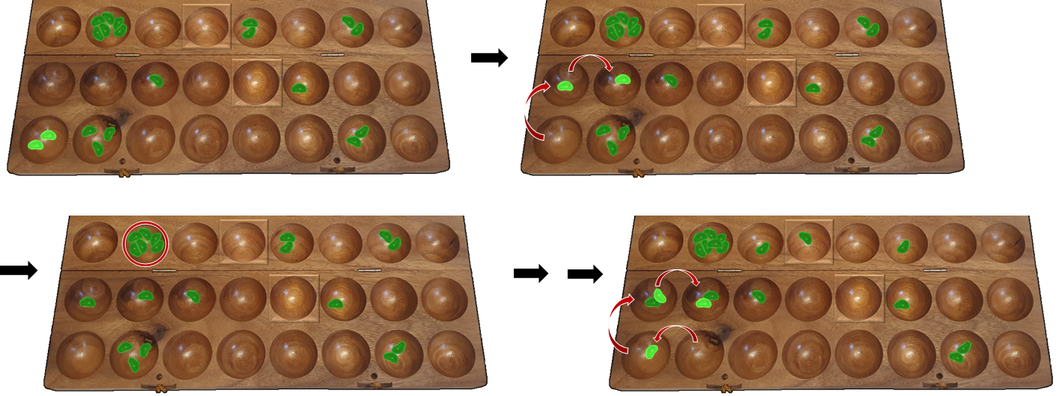

*Example: (1) The player is not able to harvest. The player cannot start from the inner row, so he executes a move without harvest from the 1st pit of the outer row, clockwise. (2) By that, the last seed falls into an empty pit adjacent to an opposing pit which is non-empty and the move ends. In the current situation, this non-empty pit of the opponent is the only pit which is harvestable for the player. (3) This blocks the opponent’s pit and he is not allowed to start a move from there, to prevent the seeds from being harvested. He is also not allowed to do this indirectly with a move starting, from the current perspective, from the right-most pit to the left, which would bring it to the blocked pit after another sowing. If he still chooses to play this move, it would end in the blocked pit. (4) The player must harvest the blocked pit in his next move. He also would have to do it, if a new situation occurred with alternative harvests.*

## The house (“nyumba“)

If a player still owns a functional house at the start of the 2nd phase, thus not having it emptied in the 1st phase, and containing at least 6 seeds, it still stays a functional house.

However, the privileges from the 1st phase are no longer exists, e.g., deciding whether to stop a move there.

But it gains a new privilege: It must not be subject of blocking as long as it stays a functional house.

# End of game

The game ends immediately, if during a move or after a move either the inner row of a player does not contain any seeds or if there are no pits containing more than 1 seed. Additionally, a player may give up.

The victorious player calls out “bao hamna”, which means “game over”.

# Variation Bao for beginners (“Bao la Kujifunza” [8])

As a variant with simpler rules, „Bao la Kujifunza“ could be played.

Here, no sowing phase takes place, so the game starts directly with the harvesting phase.

As a setup, all 64 seeds get distributed on the board, each pit containing 2.

Furthermore, there are the following simplifications:

* There is no house (“nyumba”), so there is also no need of a special pit on the board. By that, all the rules relating to the house are not applicable (e.g., restricting pit selection or stopping a move).
* There is no blocking (“kutakatia”), so the opponent is always allowed to select and empty any valid pit.

All other general rules and rules of the 2nd phase (“mtaji”) from “Bao la Kiswahili” are still in place.

# Variation Bao for kids (“Hus bao”[9])

For an even simpler variant, which is also be played by kids, the same setup as for “Bao la Kujifunza” is used (see previous chapter).

Additionally, there are the following simplifications:

* There is no distinction between moves with capture and without capture. A harvest is also allowed in the course of a move if the move did not start with a capture. And for a move, any pit may be selected which contains at least 2 seeds, no matter from which row and in which direction.
* There are no “kichwa” and sowing does not start from it. Instead, the harvested seeds from the opponent are sown together with the own seeds in the same direction. So, a harvest continues a move in the same way as a continued sowing, except that the adjacent opposing seeds are used as well.

# Contact

Alexander Rühl © 04/09/2021  
E-mail: [alexander@dieruehls.de](mailto:alex@geziefer.de) - BGA: Alex_tgiu



Sources:

<https://www.kibao.org/kanuni.php?lng=en>  
<http://www.gamecabinet.com/rules/Bao2.html>  
<https://en.wikipedia.org/wiki/Bao_(game)>  
<https://de.wikipedia.org/wiki/Bao_(Mancala-Spiel)>  
<https://sw.wikipedia.org/wiki/Bao>  
<https://mancala.fandom.com/wiki/Bao_la_Kiswahili>  
<https://mancala.fandom.com/wiki/Bao_la_Kujifunza>  
<https://mancala.fandom.com/wiki/Bao_dictionary>  
<https://www.kibao.org/doc/regole2009kiba_en.pdf>  
<https://africanlanguages.com/swahili>  
<https://translate.google.com/?hl=de&sl=sw&tl=de>  
<https://www.youtube.com/watch?v=ZPg_0Mb-BUU>  
<https://de.scribd.com/doc/237691907/Bao-Rules-Quick-Reference>

[Vessella]: Nino Vessella: “Bao Game – the almost Ultimate Guide“ (2020)

Picture: <https://pixabay.com/de/users/antekante-5115688>

Thanks to all who helped in reviewing the rules and   
tested the game on BGA.

1. “Bao of the Swahilis“ refers to the origin of the game, the Swahilis, a society in East-Africa.
2. The term “change” was used to point out the possible reversal of direction. The term “kimbi” is not directly translatable from Swahili.
3. Some rules refer to the “kichwa” also as a “kimbi”, because both of them may cause a reversal of direction, but here the terms are used separately, as common in most of the rules.
4. For counting and evenly distributing the seeds, the following method is commonly used: Additionally, to the game setup, the right-most pit of the inner row receives 2 seeds and all of the 4 pits to the right of the outer row receive 5 seeds each. This sums up to 32, being the number of seeds per player. If this method works out for both players, the correct number of seeds are in play. Then, the additionally filled pits are emptied again and those 22 seeds are put into the store.
5. In very rare cases a situation arises, where after a certain number of sowings, the initial situation is reached again and thus leading to an infinite move (see [Vassella], page 21).
6. One can imagine the house in this situation being the only remaining pit in the inner row with exactly 1 seed, thus placing a seed there would lead to sowing 2 seeds from there.
7. Exactly 16 seeds would come back to the same pit after the sowing, which then would be empty.
8. In Swahili, this is also called “Bao for women” – it remains to be hoped that this is not discriminating, but just the fact that women prefer this variant.
9. There is no official name for this variant, it is (at least in Germany) just called “Bao”.